Splunk Daily Operations Guide
Lab SIEM: DMZH1_SIEM 10.1.20.15 | Splunk Enterprise 10.6
How to check the lab's security monitoring each day. Everything here is read-only: it does not change Splunk.

The setup in brief
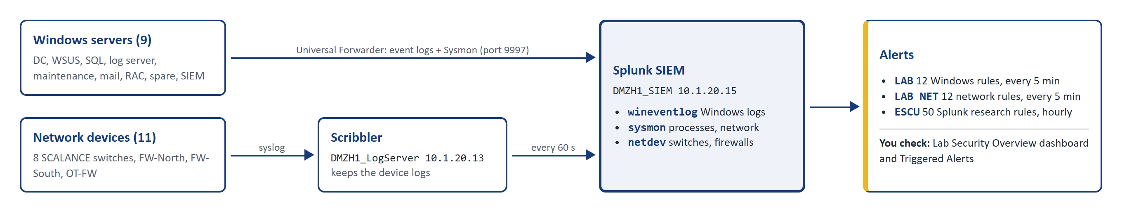
Index | What is in it | Comes from
wineventlog | Windows event logs: logons, accounts, services, PowerShell, Defender | 9 Windows servers
sysmon | Process starts, network connections, file and registry activity | 9 Windows servers
netdev | Switch and firewall logs: logins, links, config changes, denied traffic | 8 switches + 3 firewalls, via Scribbler

- Times in Splunk are UTC. Lab local time is UTC + 8 hours (06:00 in Splunk = 14:00 local).
- Alerts are checked every 5 minutes (ESCU every hour). There is no e-mail: alerts only show in Splunk.
- This guide only looks at data. Nothing in it changes Splunk.

Daily check (about 10 minutes)
- Open the Lab Security Overview dashboard (steps 1 and 2).
- Hosts reporting shows 9 and every forwarder is OK (steps 3 and 4).
- Every network device is OK and the Scribbler bridge shows ok (step 5).
- Alerts fired is 0, or open each new alert (steps 9 to 11).
- Skim config changes, failed logons, account changes and logons for anything unexpected (steps 6 to 8).
- Write down anything odd and tell the lab operator.

Step by step

Open the dashboard
Step 1 Open http://10.1.20.15:8000 in a browser and log in with your Splunk account.
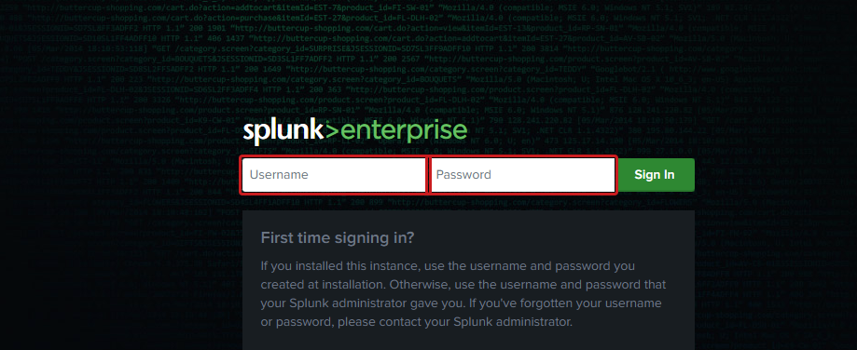
Step 2 On the home page, click Lab Security in the Apps list. It opens the Lab Security Overview dashboard.
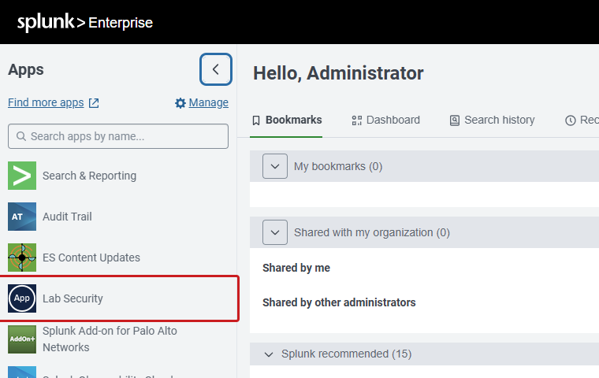

Read the dashboard
Step 3 1 Time range: last 24 hours by default; change it to look further back. 2 Host: show the Windows panels for one server only. 3 Hosts reporting should be 9 and green. 4 Alerts fired: above 0 turns red; check the alerts (steps 9 to 11).
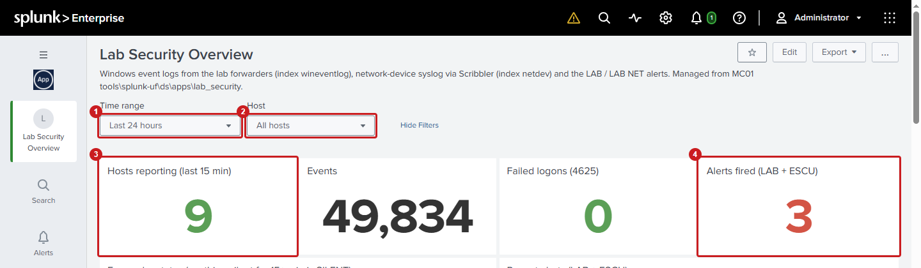
Step 4 1 Forwarder status: every server should be OK. SILENT means nothing received for 15 minutes (server off, forwarder stopped, or network). 2 Recent alerts: newest first.
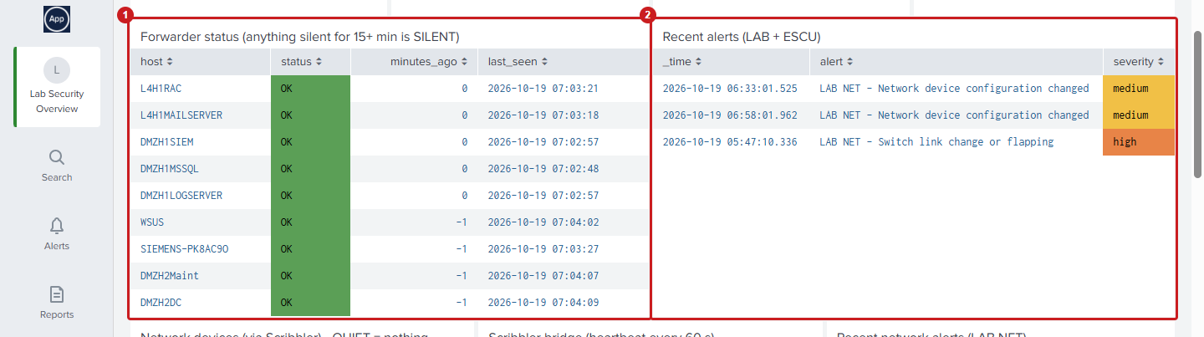
Step 5 1 Network devices (scroll the table right to see status): each should be OK. QUIET = no logs for 48 hours, NEVER = not sending logs yet. 2 Scribbler bridge must show ok. 3 Recent network alerts (LAB NET).
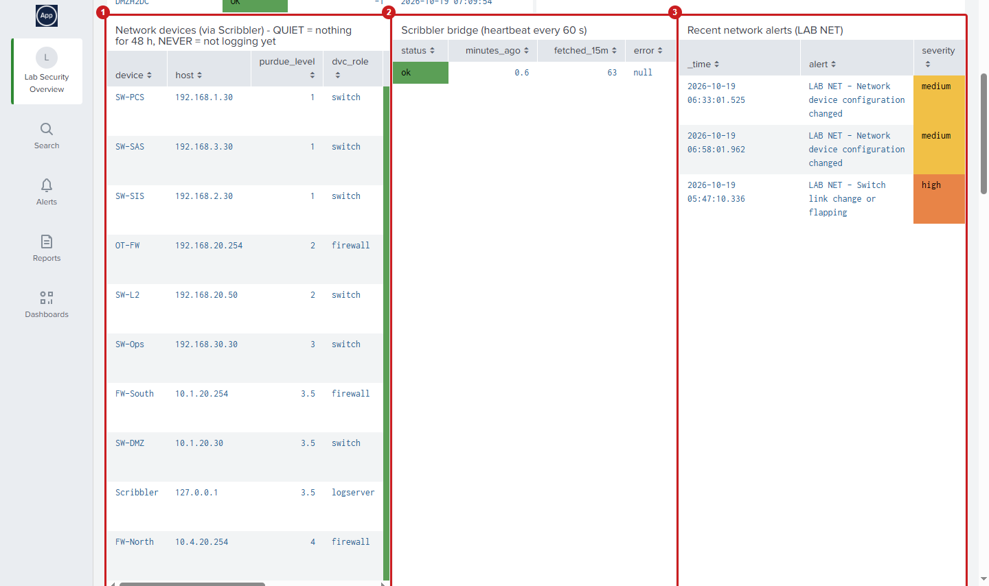
Step 6 1 Network configuration changes: who changed what on a switch or firewall. Each should be planned work you know about. 2 Switch events by type (logins, links, config). 3 Top denied sources: addresses the firewalls blocked most.
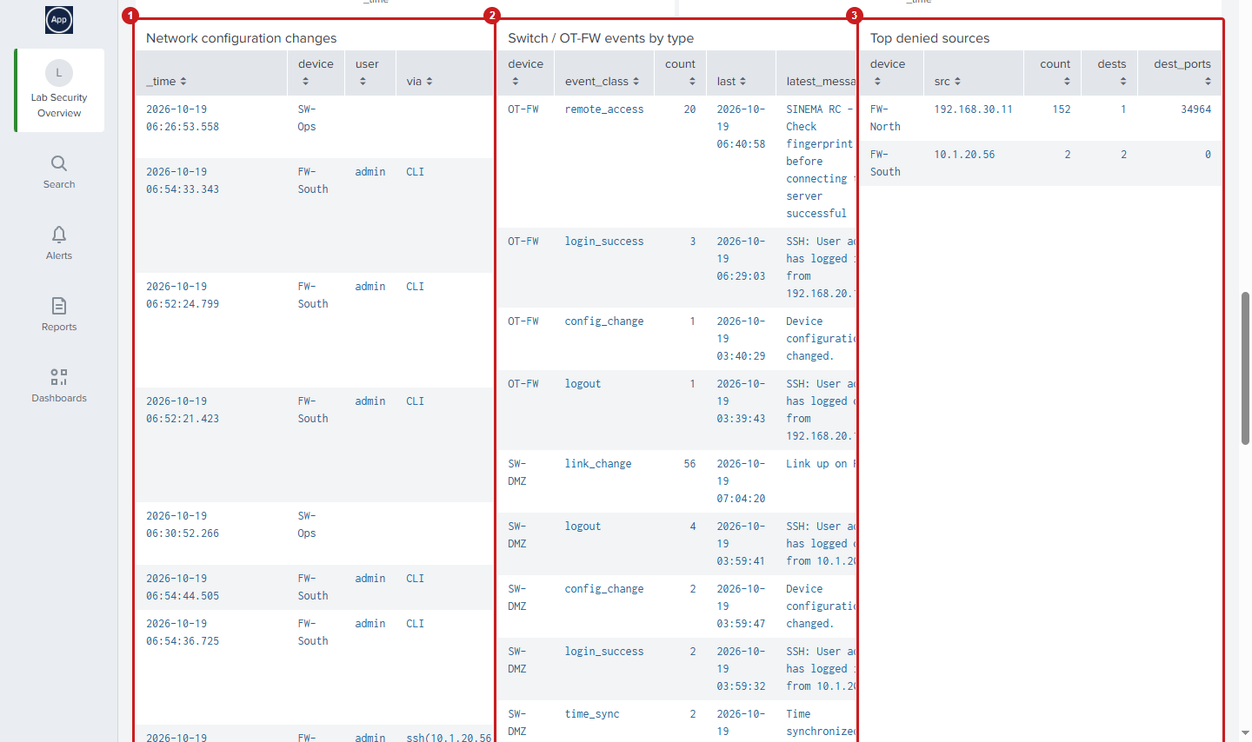
Step 7 Windows activity: 1 failed logons, 2 new users and group changes. (Shown for the last 7 days; on a quiet day these panels say *No results found*, which is normal.)
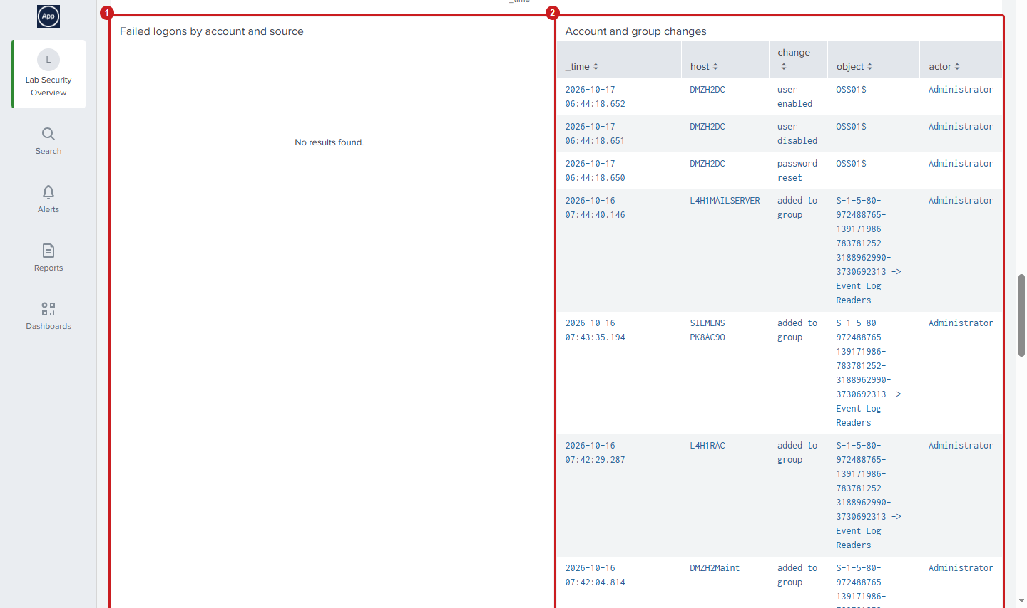
Step 8 1 RDP and console logons, 2 newly installed services. Look for accounts, sources or times you do not expect.
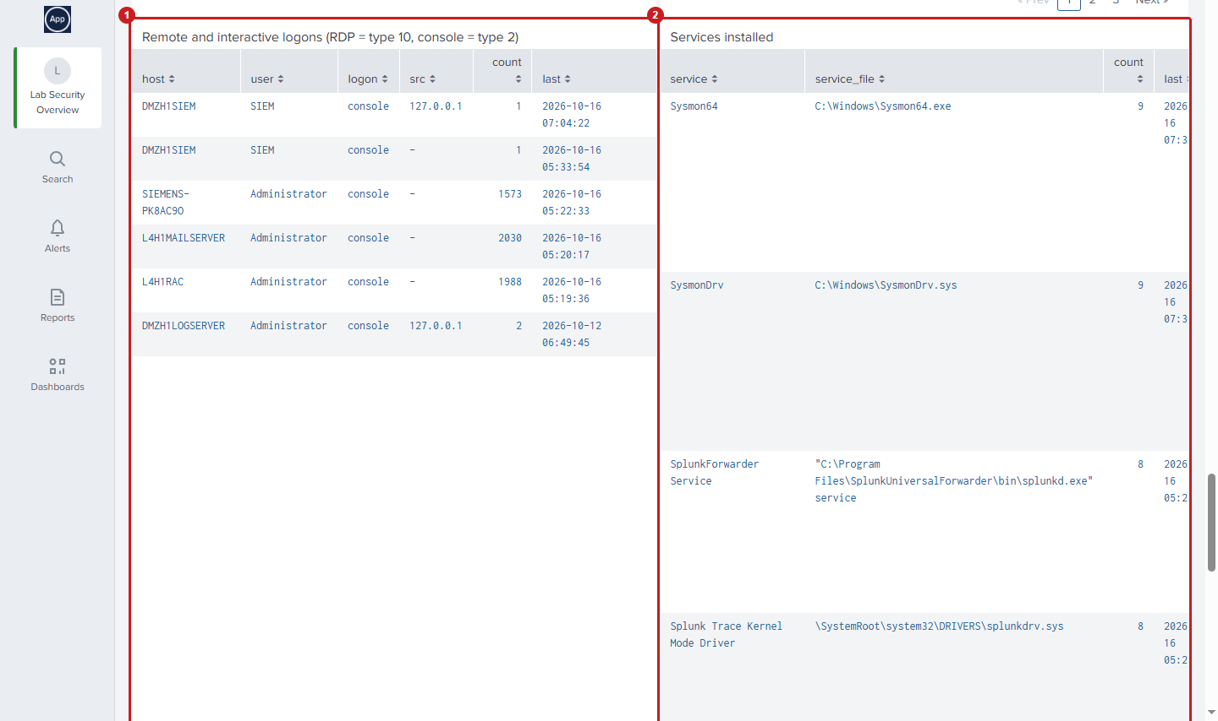

Check the alerts
Step 9 Click the Activity icon at the top, then Triggered Alerts.
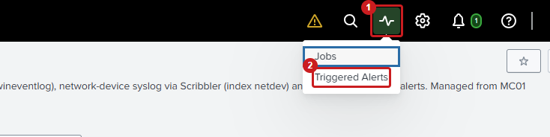
Step 10 Check App shows Lab Security: the list then has the LAB, LAB NET and ESCU alerts, newest on top. Click View Results to see what fired an alert. Do not use Edit Alert or Delete.
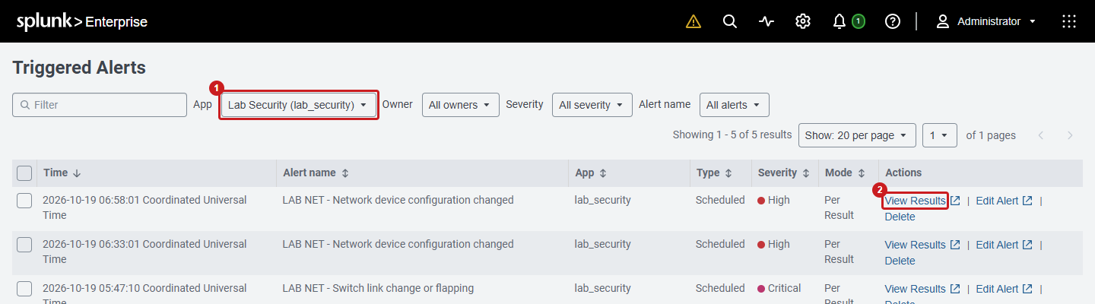
Step 11 The results open in a new tab: the time, the device or host, and what happened. Compare it with planned work; tell the lab operator about anything unexpected.
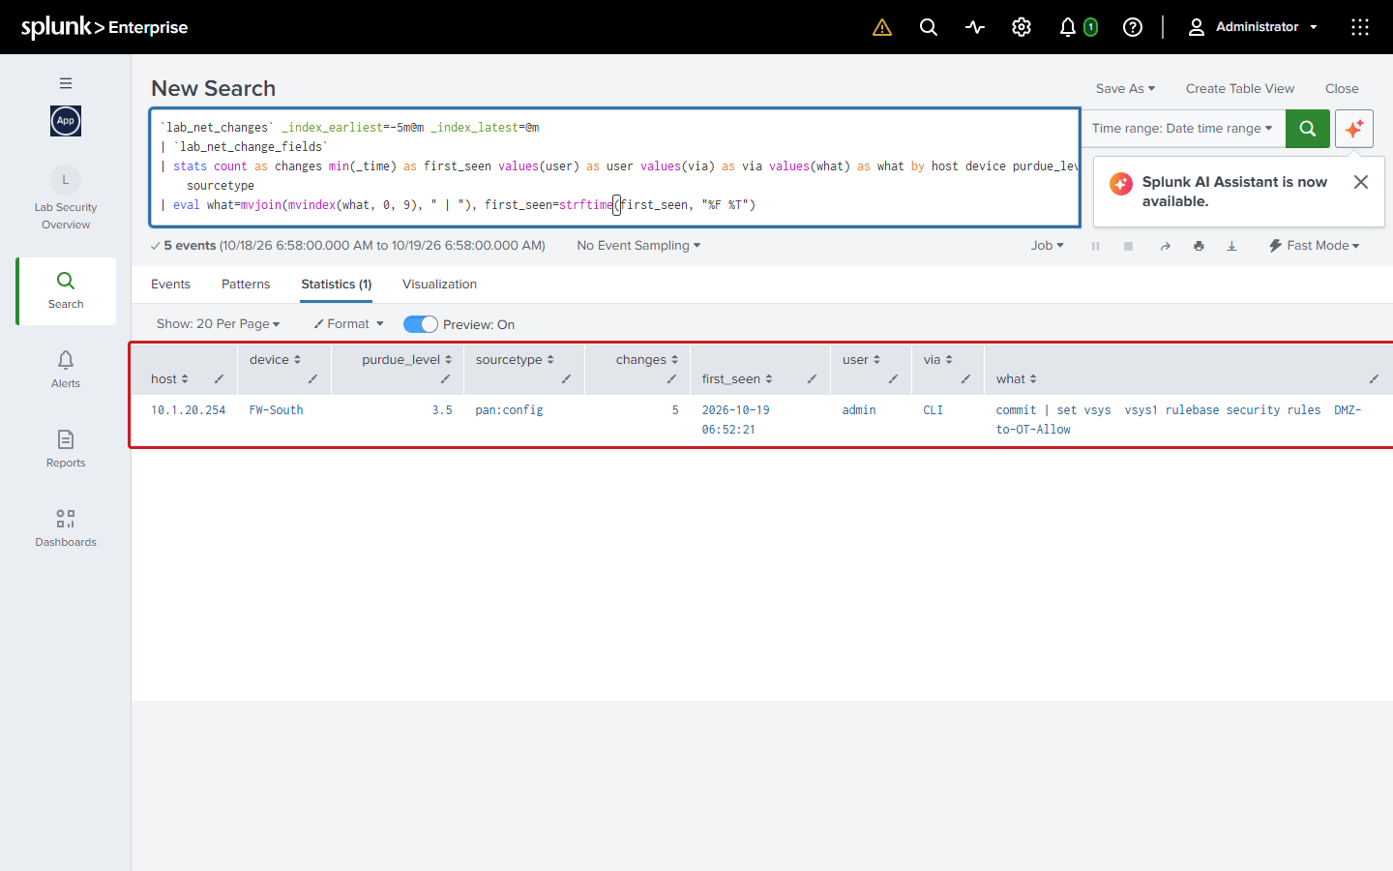

Search the logs
Step 12 Click Search in the left bar. Type a search that starts with index=, pick the time range, press Enter. Example: everything switch SW-Ops (192.168.30.30) logged in the last 24 hours.
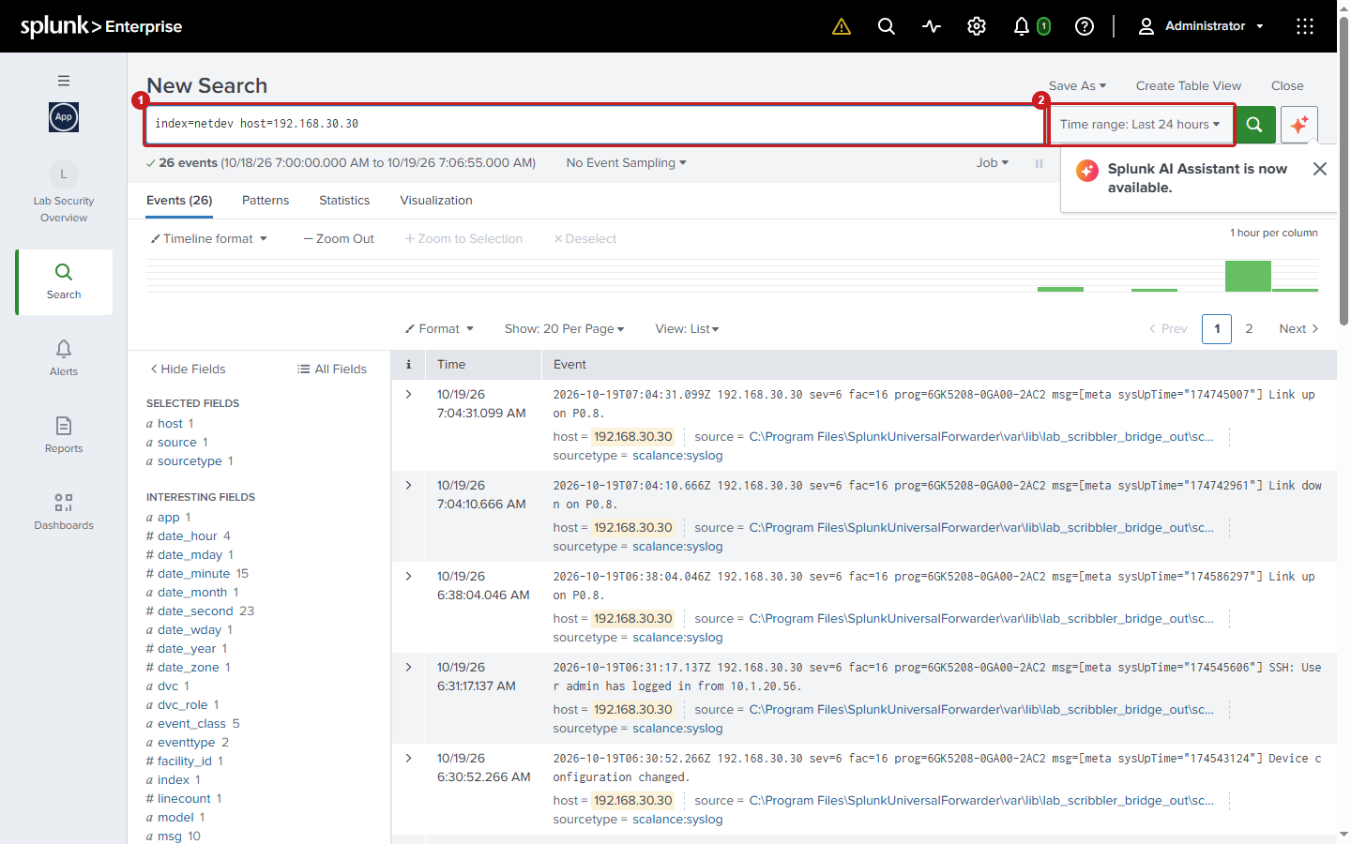
Step 13 Each event shows its time and message. Click a field on the left, such as host, to see its values; click a value to narrow the search.
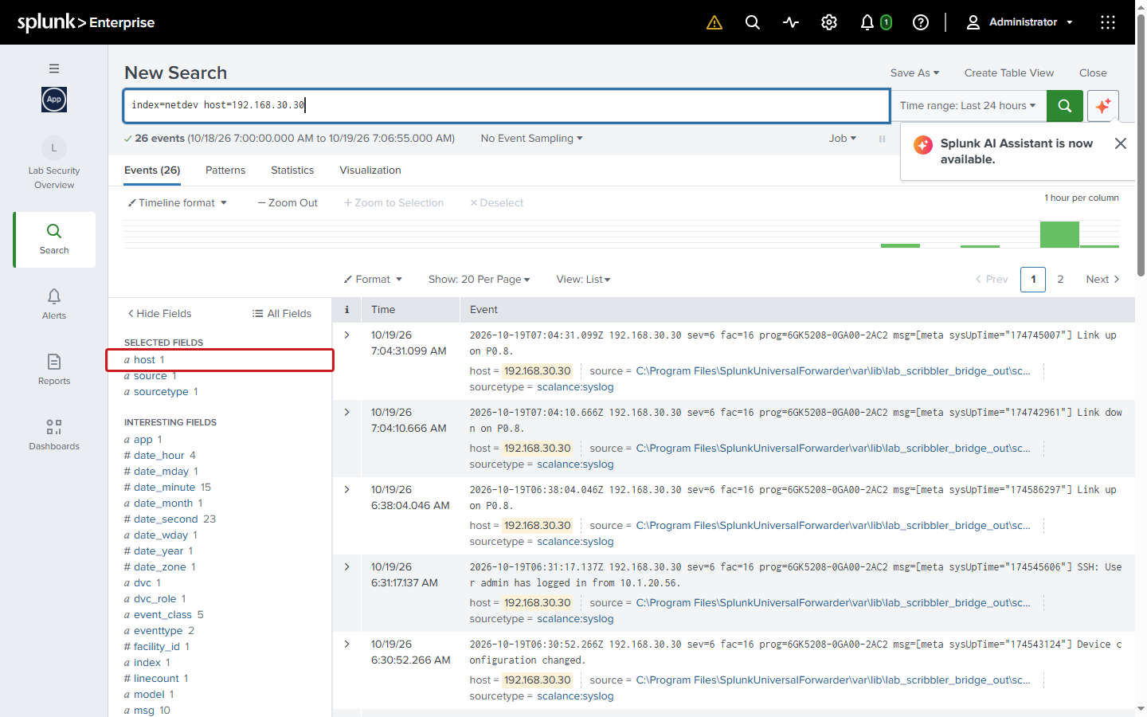

When something is not green
You see | Usually means | What to do
Hosts reporting below 9, or a host SILENT | Server off or restarting, forwarder stopped, or network path down | Check the server is running. Still silent after 15 minutes: tell the operator.
Network device QUIET or NEVER | Device off, logging off, or the path to Scribbler broken. Quiet switches log very little, so QUIET can be normal | Tell the operator if it stays QUIET for more than a day.
Scribbler bridge STALE, error or NO HEARTBEAT | Network logs are no longer reaching Splunk | Tell the operator (log server DMZH1_LogServer).
Alerts fired above 0 | A rule matched | Open it (steps 9 to 11). Planned work: note it. Otherwise tell the operator.
A config change you did not expect | Someone changed a switch or firewall | Note device, user and time; tell the operator.

Useful searches
Paste into Search, set the time range, press Enter.
Search | Shows
index=wineventlog | stats count by host | Events per Windows server
index=wineventlog host=DMZH2DC | Everything from one server
index=netdev host=192.168.30.30 | Everything from one network device (by IP)
index=netdev sourcetype=scalance:syslog | stats count by netdev_name event_class | Switch events by device and type
index=wineventlog `lab_win(Security)` EventCode=4625 | `lab_failed_logon_fields` | stats count by host user src reason | Failed logons: who, from where, why
index=sysmon host=DMZH1MSSQL | stats count by EventCode | Sysmon activity on one server (1 = process start, 3 = network)

Please don't
- Edit, disable or delete alerts, dashboards or triggered alerts.
- Restart Splunk or a forwarder. Tell the operator instead.
- Search All time without a reason: it is slow. Last 24 hours or 7 days is enough.
- Forget index=: without it a search finds nothing.

